Exercise 4: Creating and Configuring a Maven Project

**Scenario**: You need to set up a new Maven project for the library management application and add Spring dependencies.

### ****Step 1: Create a New Maven Project****

Create a new Maven project named **LibraryManagement**.

The following configuration was used:

* **Project**: Maven
* **Language**: Java
* **Group**: com.library
* **Artifact**: LibraryManagement
* 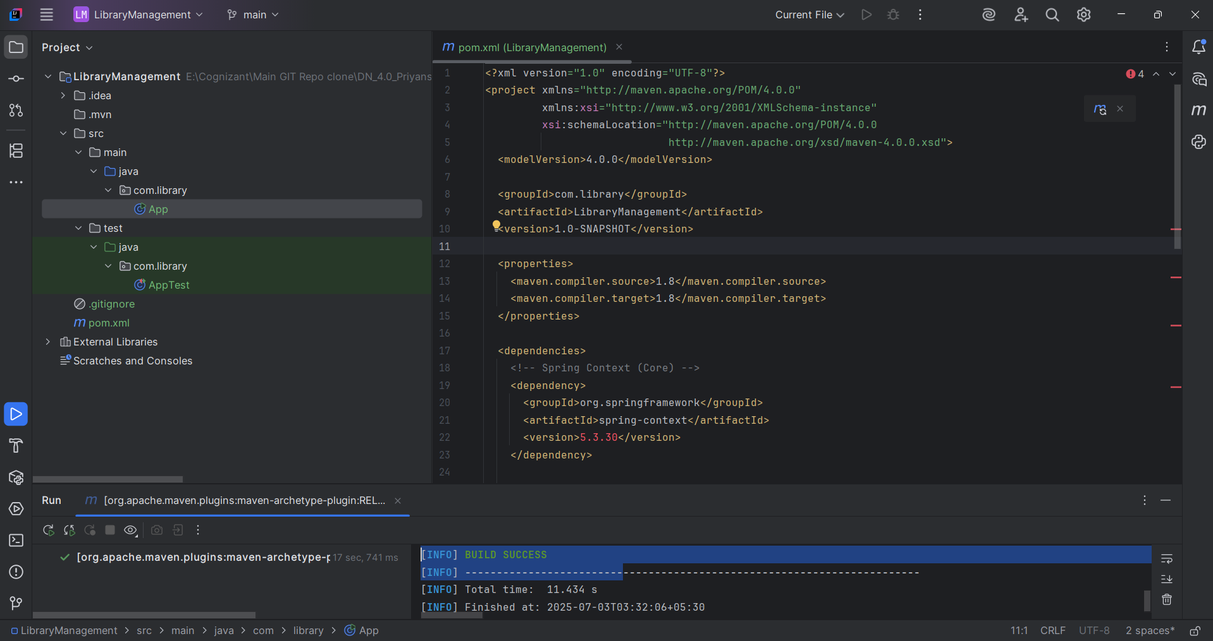**Java Version**: 8

Build Success Screenshot

### ****Step 2: Add Spring Dependencies in**** pom.xml

The following Spring dependencies were included to support the required backend functionalities:

* **Spring Context**
* **Spring AOP**
* 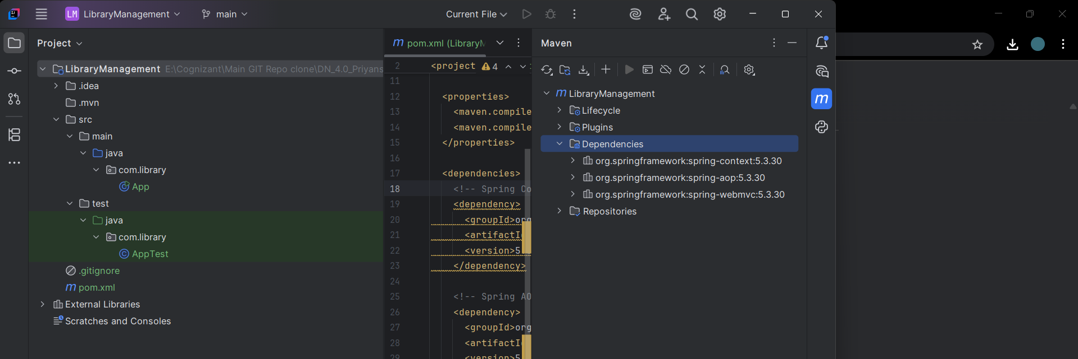**Spring WebMVC**

## ****Step 3: Configure Maven Plugins****

To ensure compatibility with **Java 1.8**, the Maven Compiler Plugin was added to the pom.xml with the following configuration:

<plugins>  
 <plugin>  
 <groupId>org.apache.maven.plugins</groupId>  
 <artifactId>maven-compiler-plugin</artifactId>  
 <version>3.8.1</version>  
 <configuration>  
 <source>1.8</source>  
 <target>1.8</target>  
 </configuration>  
 </plugin>  
 </plugins>  
 </build>  
</project>

Hence all the instructions are implemented.